**Problem and the Solution**:

The existing billing system does not provide a clear approach to the user in accessing and providing enough options to handle the bills, if there are any discrepancies the user is left with no other option than to visit the Electricity Department to get his issues resolved.

This conventional way of handling the bills is handled with the new Electricity Billing System by giving a simplistic user interface to access his/her bills and also taking care of the any queries related to not just the latest bill but also the consumer’s last 4 bills.

The Application displays the latest Bill, viewing all the bills in a tabular view and also providing the user to raise a complaint for any disparity.

**Audience:**

**1. Consumer**

Note : Consumer Registration should be done by the system Administrator to access the Bills.

You will be displayed with the latest Bill as shown below in the figure after you enter your consumer ID.

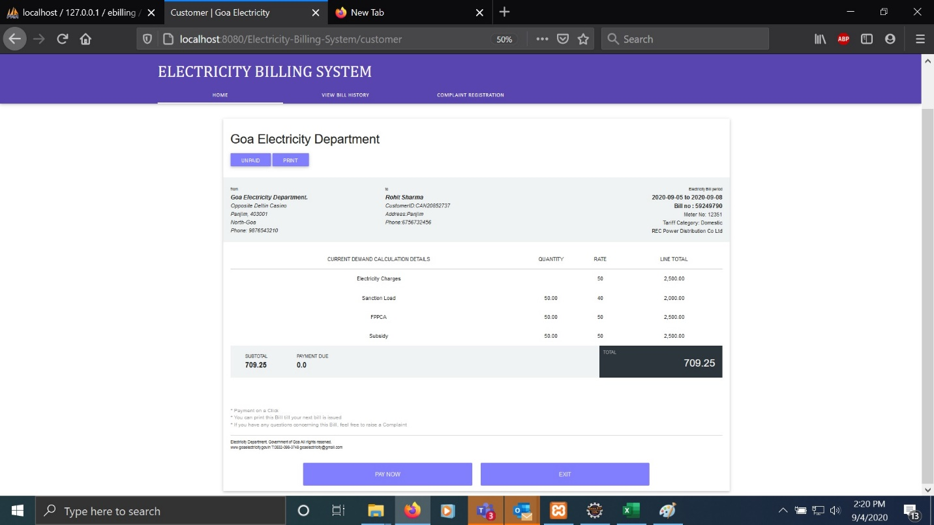

**Viewing All the Bills:**

You will see the 3 tabs just below the header , Click on the View all Bills tab and you will see your previous bills in a tabular form as shown below. You will also be shown the status of your Bill payment.

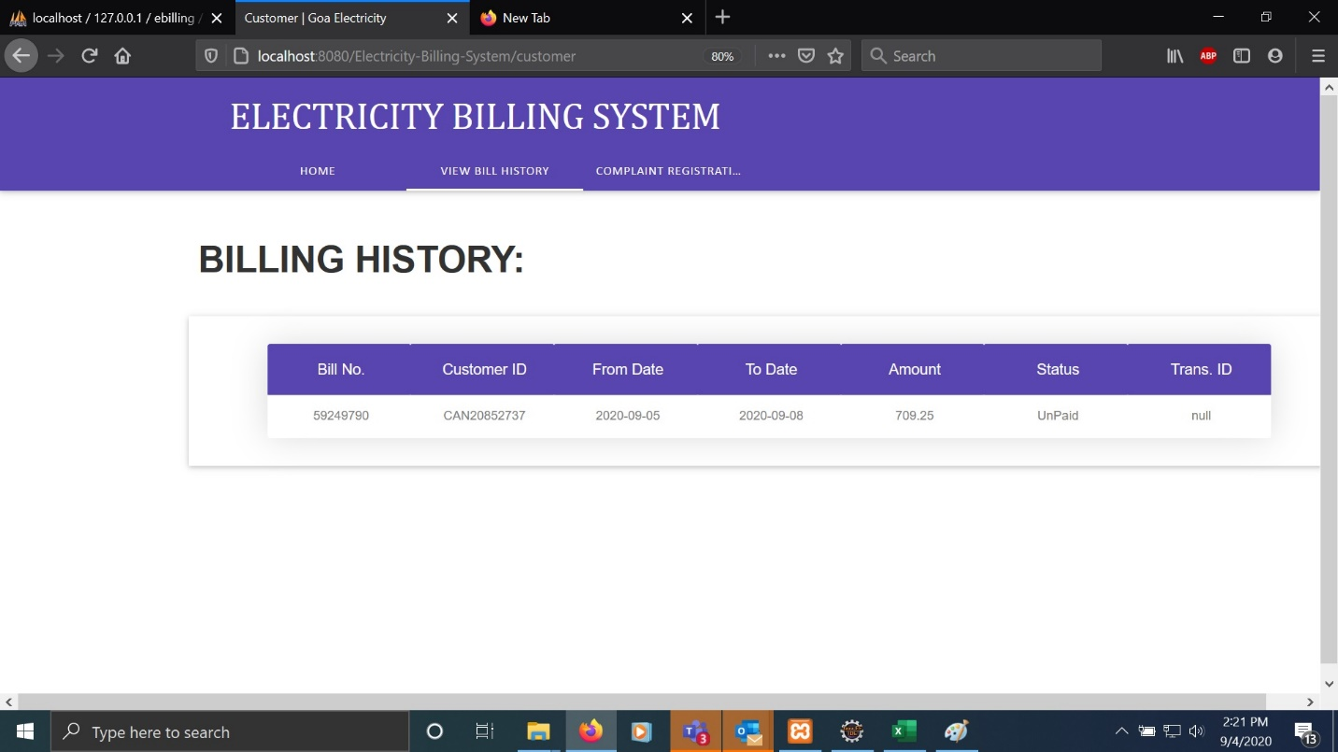

**Raise a Complaint:**

If any discrepancies you can register your complaint in the complaints tab from the home screen of the application.

Again from the tabs just below the header select on Register Complaint. And the following screen appears.

The details would be auto filled, you just need to select the bill number from the dropdown as shown below

After that you need to enter the description for your complaint and you need to fill the expected bill amount as shown below and then click submit.

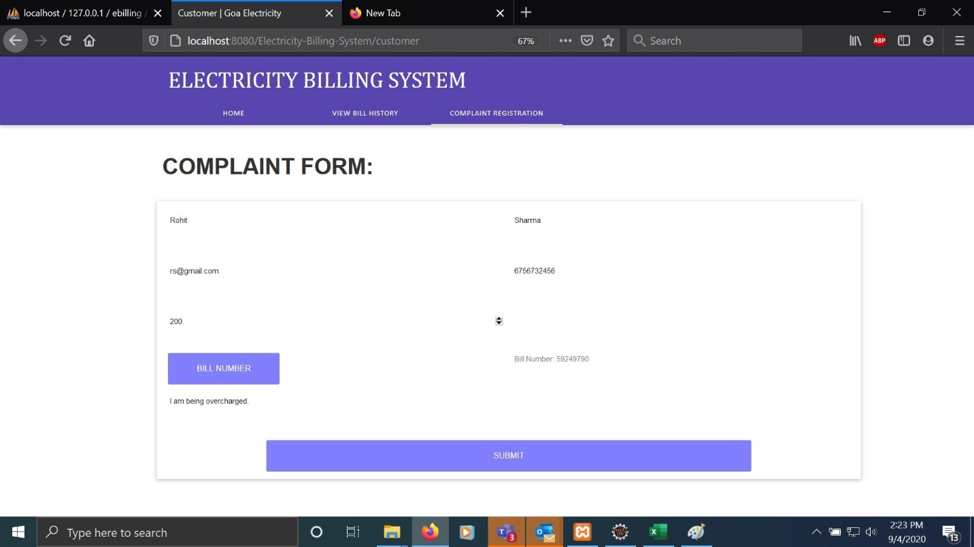

**2. Administrator**

The is administrator can log in using the credentials given to him.

After the admin logs in he is displayed with the screen consisting of tabs namely

* Uploading data gathered from the field person.
* Viewing and resolving complaints.
* Registering a new customer

To generate the bills the Administrator has to input the data gathered by the field person in a comma separated values (.csv) file.

Click on browse button and select the file from the window pop up as shown below and click upload.

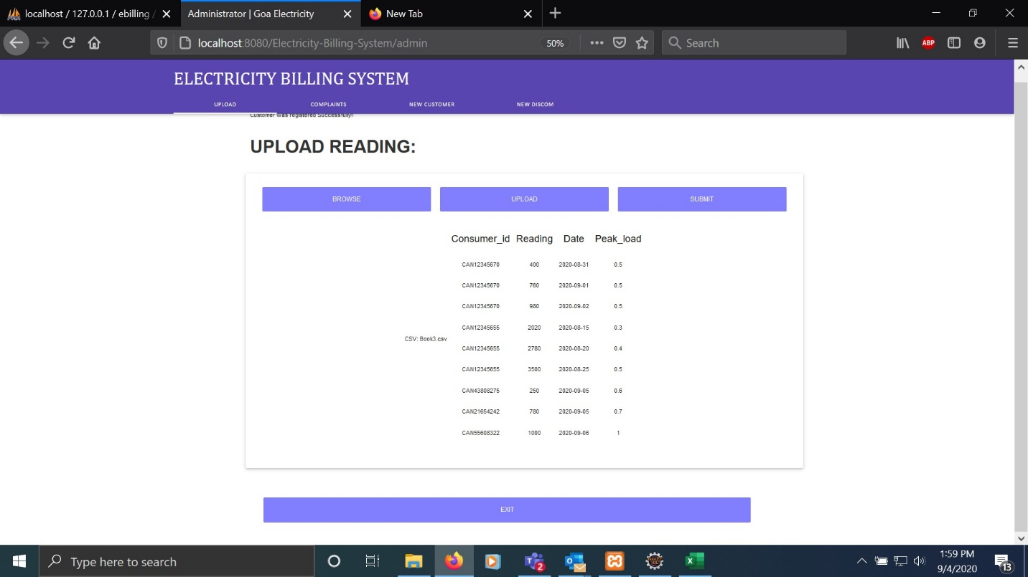

Then the data you import will be shown in a tabular form. Finally Clicking on submit will generate the Electricity Bills in the background.

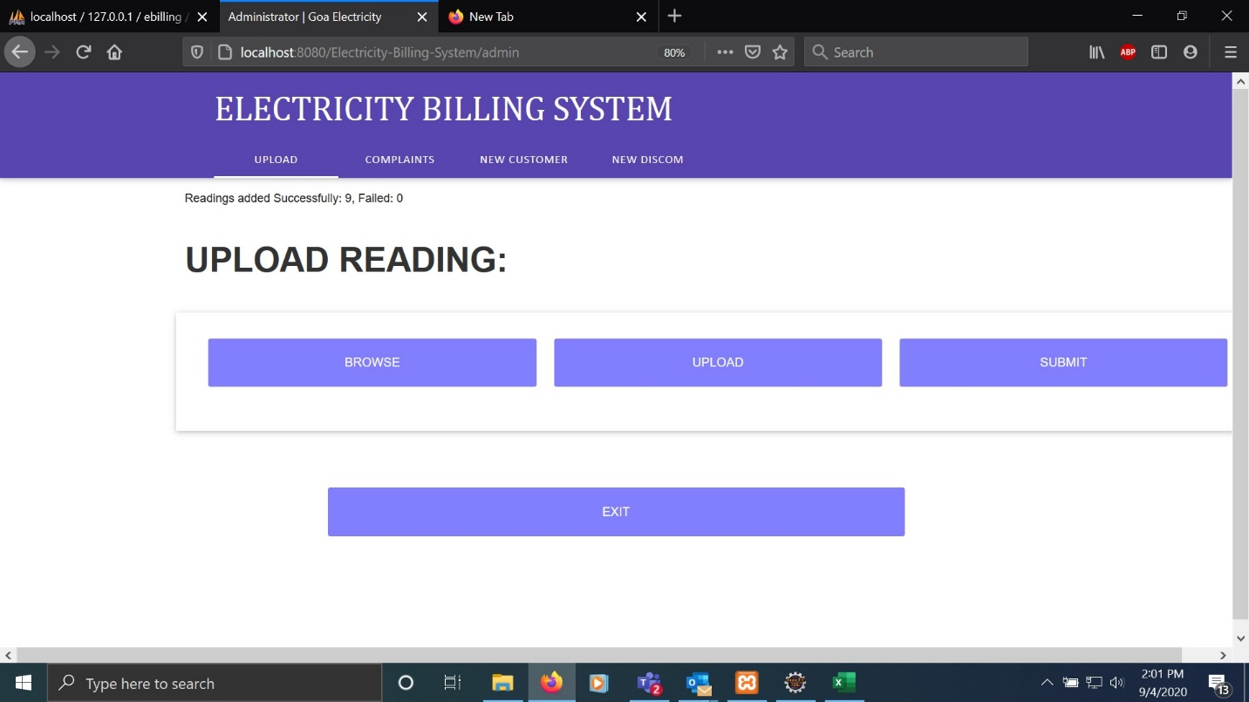

To View the complaints you need to click on the Complaints tab and you will be displayed with all the complaints shown below.

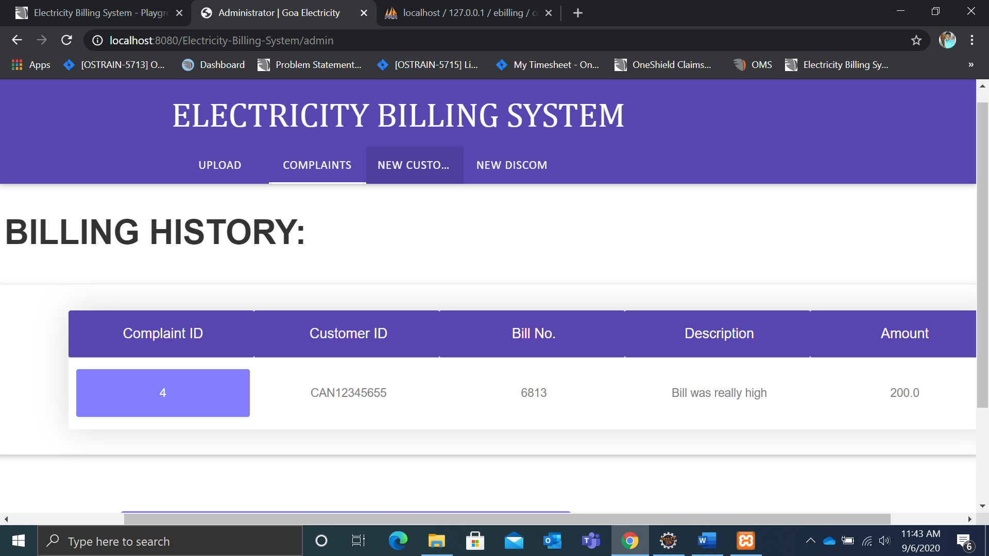

Next To resolve a specific complaint you need to click on a the consumer ID and you get redirected to the details of that complaint as shown below.

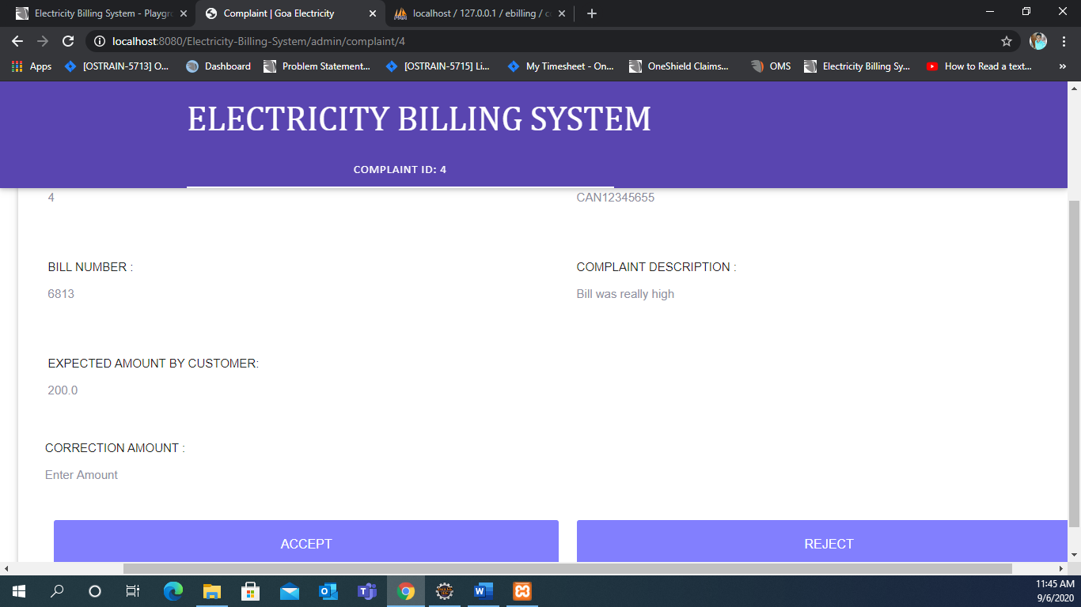

Click on Accept or Reject complaint accordingly based on the validation of the expected amount entered by the user.

You can register a new consumer by clicking on new customer registration tab and adding all the mandatory fields and finally clicking on the Submit button.

